Train Reservation System
Project: RailBook | Technology: HTML, CSS, JavaScript (localStorage)

Aim
To develop a train reservation system supporting class-wise fares, seat availability, multiple passengers, waiting list and cancellation with refund.

Algorithm
- Start: load trains, stations and bookings from localStorage.
- User selects source, destination, date and class.
- Compute fare for the class and distance; compute availability (confirmed / RAC / waiting).
- Add passenger rows (name, age, gender) and confirm booking; assign berth or waiting number.
- On cancellation, calculate refund based on time before departure.
- Re-allocate: promote waiting-list passengers to confirmed when a seat is freed.
- Generate ticket (PNR) and save data. Stop.

Result
The Train Reservation System was implemented successfully using HTML, CSS and JavaScript. All modules (login, role-based pages, data entry, search/booking and admin management) work correctly in the browser, and data persists using localStorage.

Implementation (Output Screenshots)
Home page
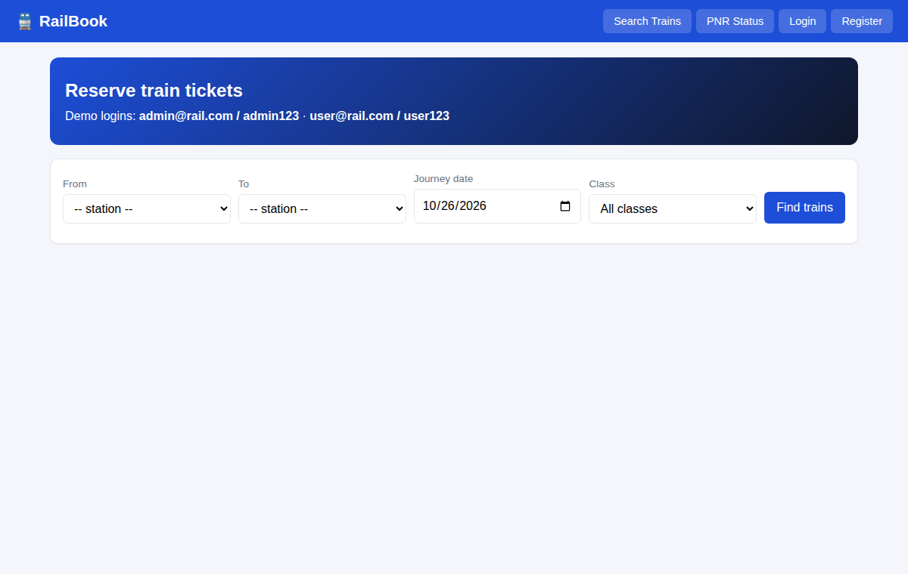
After login (admin / dashboard)
